02.60 SENIOR’S FINAL CHECKLIST

The following describes the functionality and features included in Probe Audit Premium+

Objective

The objective of this document is to provide the senior member of the engagement team with a comprehensive checklist to confirm that all audit procedures have been completed, all documentation requirements have been met, and all relevant matters have been appropriately addressed before finalising the engagement.

The following key concepts of the Probe Audit Premium+ Methodology are set in this document:
- First-level quality assurance review of completed audit work (ISA 220)
- Verification that all audit procedures have been completed, documented, and audit objectives met
- Confirmation that all required communications and representations have been obtained

Document placement

Document 02.60 – Senior’s Final Checklist can be found in the Finalisation folder in the Caseware document manager.
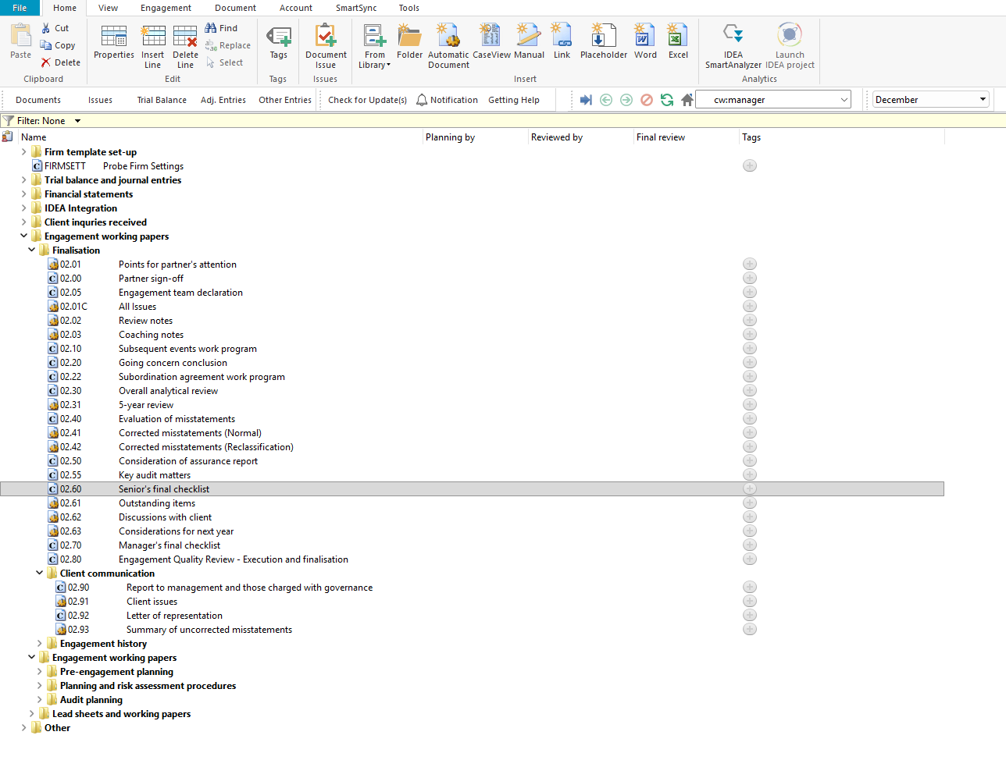

Document content

This document is designed to be a checklist type document that provides the senior member of the engagement team with 52 considerations to confirm that all audit procedures, documentation requirements, and reporting obligations have been completed before finalising the engagement.

The checklist covers a wide range of ISA requirements including ISA 200 (Overall Objectives), ISA 210 (Agreeing the Terms), ISA 230 (Audit Documentation), ISA 240 (Fraud), ISA 250 (Laws and Regulations), ISA 260 (Communication with Those Charged with Governance), ISA 315 (Identifying and Assessing Risks), ISA 320 (Materiality), ISA 330 (Responses to Assessed Risks), ISA 450 (Evaluation of Misstatements), ISA 500 (Audit Evidence), ISA 520 (Analytical Procedures), ISA 560 (Subsequent Events), ISA 570 (Going Concern), ISA 580 (Written Representations), and ISA 700 (Forming an Opinion).

This document is divided into different bookmarks in the document map to assist you in completing the senior’s final checklist:

Considerations
[Screenshot: Document map showing bookmarks]

Layout
Column | Input Required | Outcome
Considerations
Considerations | No input is required in this column. The considerations are pre-populated and present 52 questions covering all aspects of the audit that the senior member of the engagement team must confirm have been completed. The questions address contracts and agreements, compliance with laws and regulations, internal control deficiencies, audit programs, opening balances, financial statement presentation, representations, misstatements, subsequent events, going concern, documentation, fraud, and file assembly. | No impact on the engagement file. Documents the considerations to be confirmed by the senior member of the engagement team before finalising the engagement.
Yes/No | Select 'Yes' or 'No' to confirm whether each consideration has been addressed. All considerations should be answered 'Yes' before the engagement is finalised. | No impact on the engagement file. Documents the senior’s confirmation that each consideration has been addressed.
Performed by | Enter the name or initials of the engagement team member who confirmed each consideration and the date of confirmation. | No impact on the engagement file. Records who confirmed each consideration and when it was confirmed.
Ref | Enter a cross-reference to the relevant working paper or supporting documentation for each consideration. | No impact on the engagement file. Documents the cross-reference for the engagement file.

Document outcomes

The senior member of the engagement team must confirm that all 52 considerations have been addressed by answering 'Yes' or 'No' to each question. All considerations should be answered 'Yes' before the engagement is finalised. Where a consideration is answered 'No', the engagement team must ensure that the matter is appropriately resolved before the engagement file is assembled and locked down. The checklist serves as evidence that the senior has reviewed all critical aspects of the engagement including compliance with ISAs, adequacy of documentation, communication with management and those charged with governance, and the appropriateness of the audit opinion.

Group Audits

When the engagement type was selected as 'Group Audit Single' or 'Group Audit Multiple', the senior’s final checklist applies to the group engagement. The engagement team must ensure that all considerations are addressed in the context of the group audit, including the involvement of component auditors and the adequacy of group audit documentation.

IN CONCLUSION

Features

The following features are available in the document:

Insert or delete a comment, see page F3

Guidance, see page F16

Freeze, see page F19

